FLIGHT CONDITION: SUPERSONIC
Question 1 - SAS
- Current Handling Qualities
According to the flying qualities, McDonnell Douglas F4 is a Class IV aircraft. The flight condition makes it a Category B aircraft and it needs to fulfill the following lateral characteristics’ requirements (assuming Level 1 flying condition);
$${Roll Mode Time Constant: τ}_{roll}≤1.4 sec$$
$${Spiral Mode Time Constant: τ}_{spiral} ≥28.9 sec$$
$$Dutch Roll Mode Damping Ratio: \left(ζ_{DR}\right)≥0.08$$
$$Dutch Roll Mode Frequency: (ω_{DR}) ≥0.5$$
The state space is:
$\left[\begin{aligned}\begin{aligned}\begin{aligned}∆\dot{β} \\ ∆\dot{ρ}\end{aligned} \\ ∆\dot{r}\end{aligned} \\ ∆\dot{φ}\end{aligned}\right]=\left[\begin{matrix}-0.0764 & 0 & -1 & 0.01848 \\ -8.912 & -0.792 & 0.1584 & 0 \\ 5.737 & 0 & -0.1841 & 0 \\ 0 & 1 & 0 & 0\end{matrix}\right]\left[\begin{aligned}∆β \\ ∆ρ \\ ∆r \\ ∆φ\end{aligned}\right]$ $+\left[\begin{matrix}0 & 0.005457 \\ 5.347 & 1.069 \\ -0.05737 & -1.594 \\ 0 & 0\end{matrix}\right]\left[\begin{aligned}∆δ_{a} \\ ∆δ_{r}\end{aligned}\right]$
Characteristic Equation
$s^{4}+1.0525s^{3}+5.9577s^{2}+4.7196s+0.0135$
Longitudinal Characteristics of Motion
Characteristics | Roll Mode | Spiral Mode | Dutch Roll Mode
Eigen Values | $$λ_{roll}= -0.816$$ | $$λ_{spiral}= -0.00288$$ | $$λ_{DR}= -0.117±2.40i$$
Damping Ratio | $$ζ_{roll}=1$$ | $$ζ_{spiral}=1$$ | $$ζ_{DR}=0.0487$$
Frequency (rad/s) | $$ω_{roll}=0.816$$ | $$ω_{spiral}=0.00288$$ | $$ω_{DR}=2.40$$
Time Constant (s) | $$τ_{roll}=1.23$$ | $$τ_{spiral}=348$$ | $$τ_{DR}=8.56$$

- Open Loop Responses & Parameters
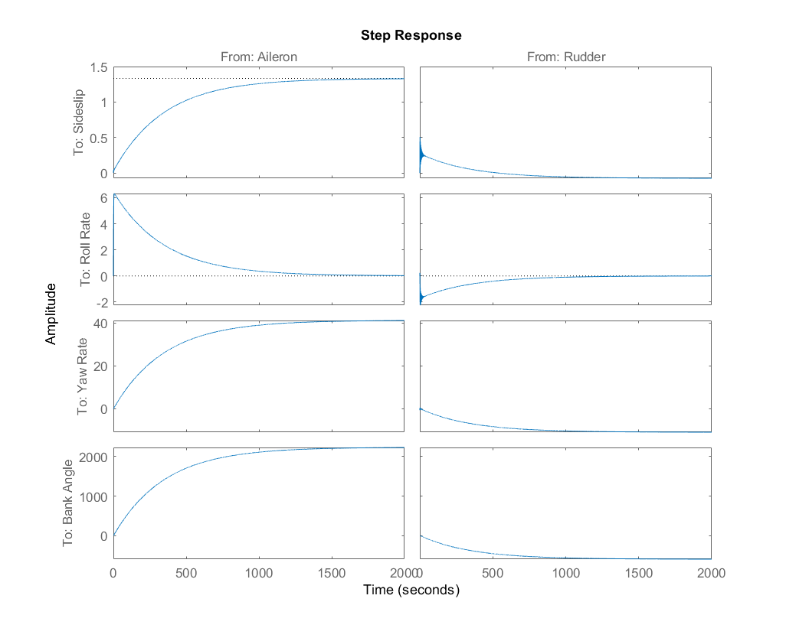
Zoomed in open loop step responses:
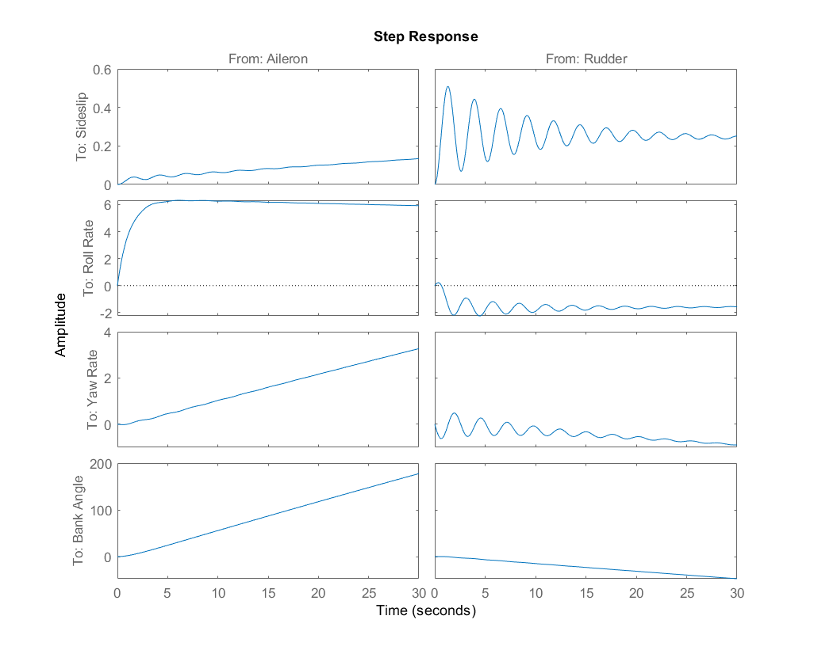
It was observed above that the Dutch role made damping had to be increased whole other criteria was fulfilled. Hence a yaw damper is required. Open loop step response from Rudder to Yaw Rate using SISO tool.
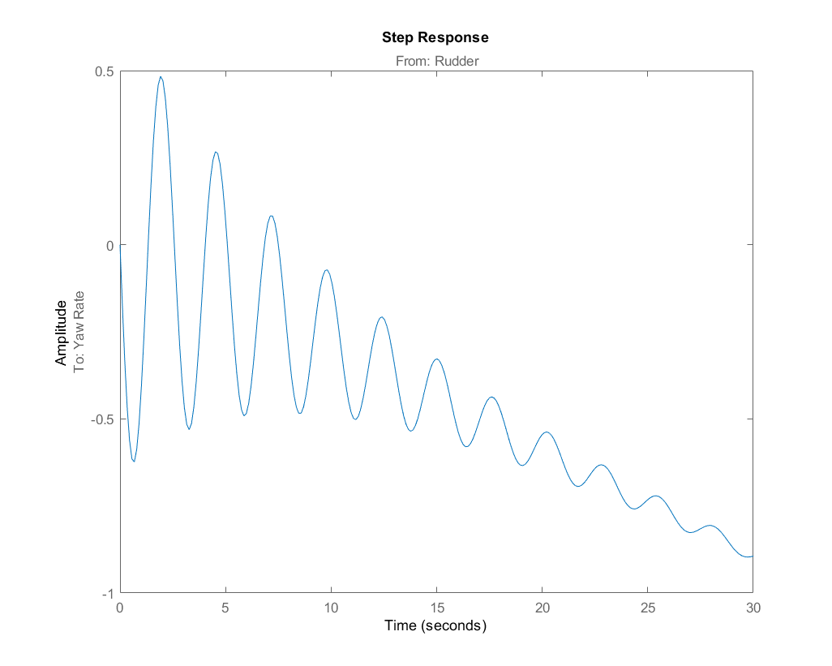
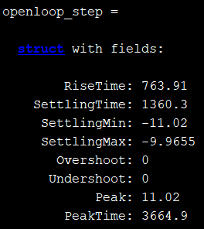
- SAS Design
The roll mode and spiral mode time constants are within their respective required ranges. The Dutch roll mode frequency is also within the required range. However, the Dutch roll mode damping ratio does not fulfill the given criteria and is below the required minimum limit. Since here we are required to make coordinated turn hold autopilot and heading autopilot, we need roll mode characteristics to be good meaning there should be relatively fast response and the aircraft should directly go to required bank angle with no overshoot and extra oscillations. Therefore, first a roll damper will be designed to improve the roll mode characteristics and then a yaw damper will be added to improve the Dutch Roll mode characteristics and bring them under the required limits.
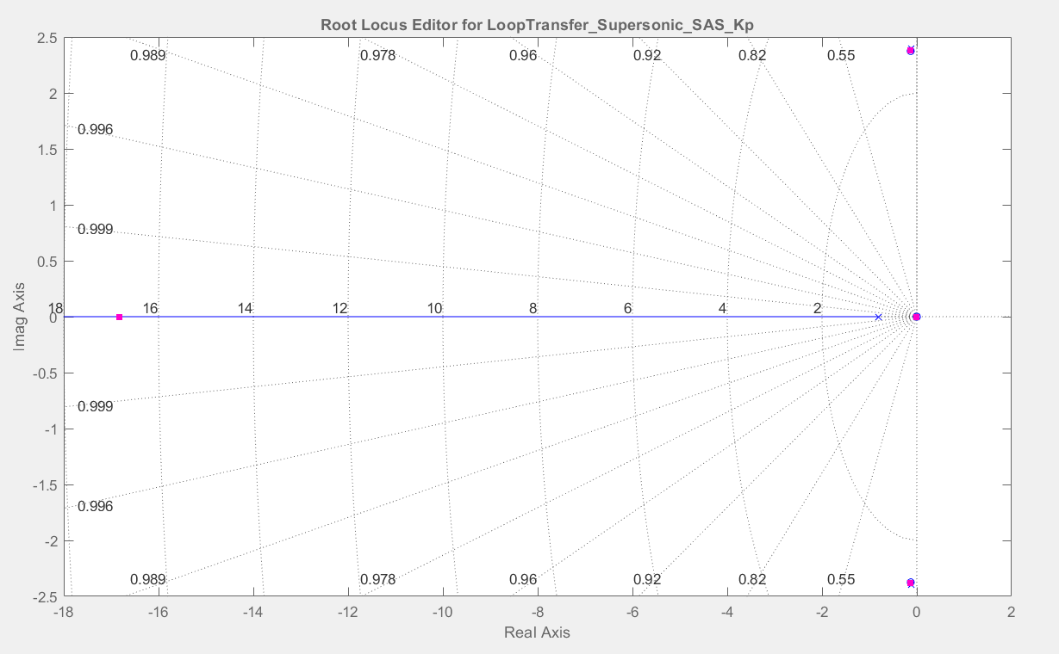
Above is the root locus for the roll damper gain Kp. It can be seen that both Dutch roll mode and spiral mode remain insensitive to the roll damper as their poles are very close to zeros. The gain value chosen is Kp = 3. This gives sufficient roll mode characteristics. Next, the yaw damper was added and its new root locus is shown below.
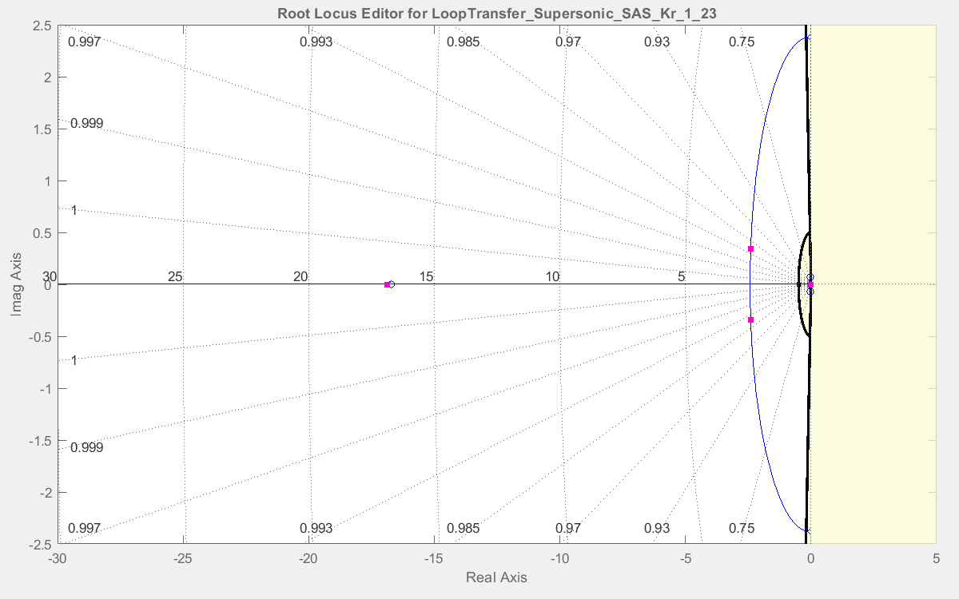
The Dutch roll mode characteristics have improved and now fall under the required limits. The gain value chosen is Kr = -2.88. Below are the new system characteristics after designing the SAS. It can be observed that all flight requirements are now being fulfilled.
Characteristics | Roll Mode | Spiral Mode | Dutch Roll Mode
Eigen Values | $$λ_{roll}= -16.9$$ | $$λ_{spiral}= -0.00446$$ | $$λ_{DR}= -2.4±0.339i$$
Damping Ratio | $$ζ_{roll}=1$$ | $$ζ_{spiral}=1$$ | $$ζ_{DR}=0.99$$
Frequency (rad/s) | $$ω_{roll}=16.9$$ | $$ω_{spiral}=0.00446$$ | $$ω_{DR}=2.43$$
Time Constant (s) | $$τ_{roll}=0.0593$$ | $$τ_{spiral}=224$$ | $$τ_{DR}=0.416$$

- Closed Loop Responses & Parameters
Step Responses of Augmented & Un-augmented systems
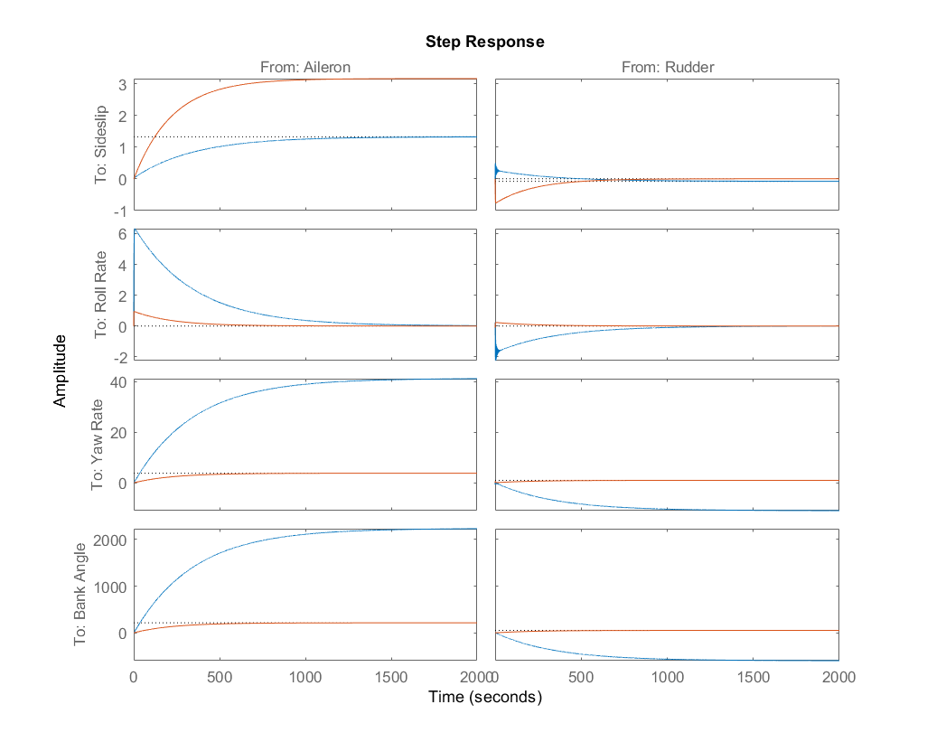

Zoomed in open loop step responses:
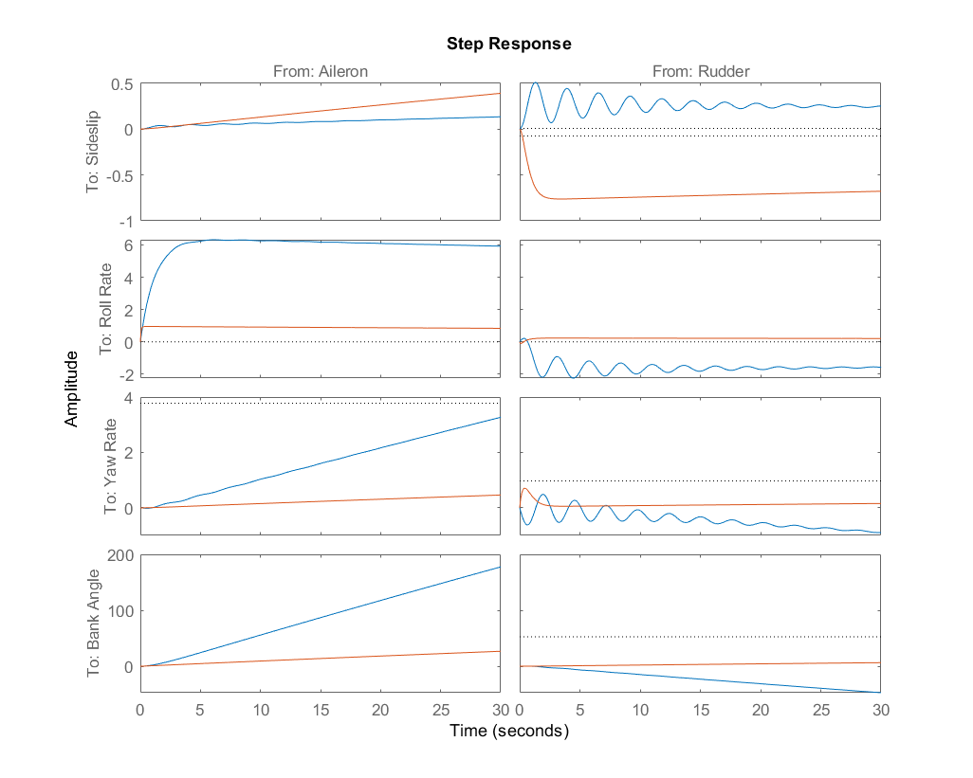
Yaw Damper Step Response using SISO Tool
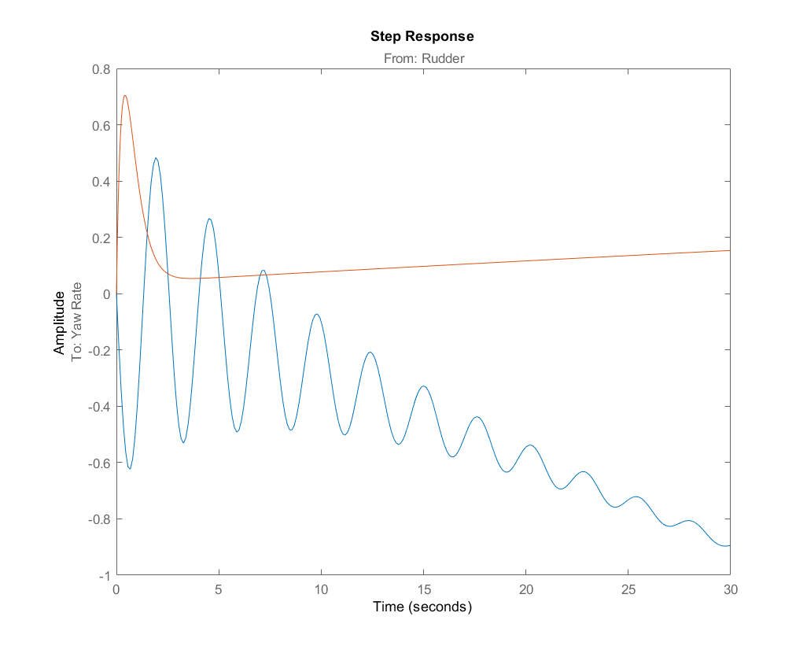
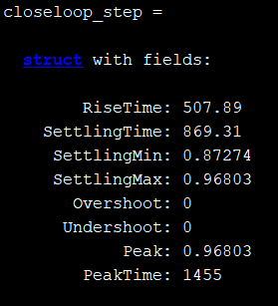
Impulse Responses of Augmented & Un-augmented systems
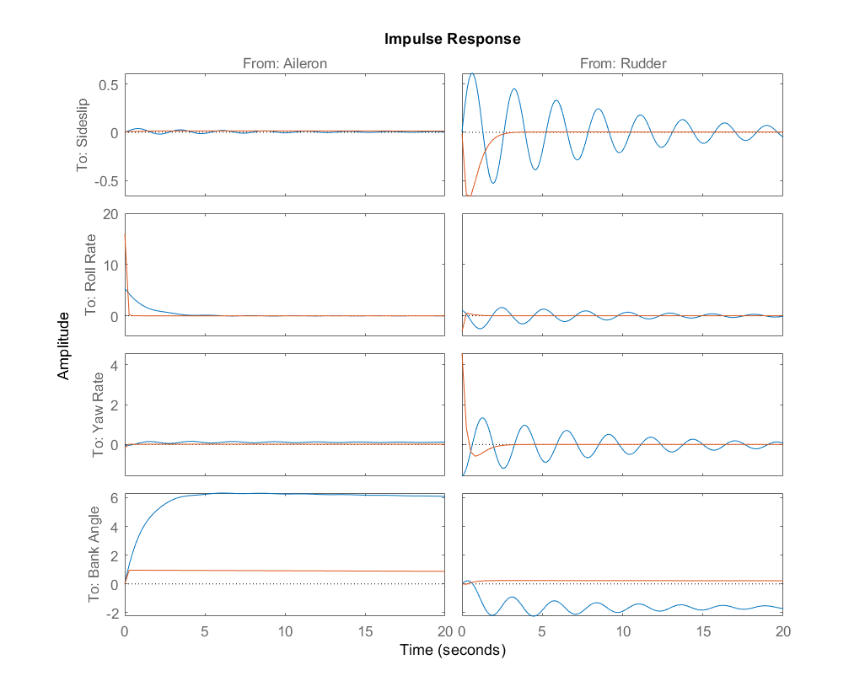

- Simulink Model for SAS
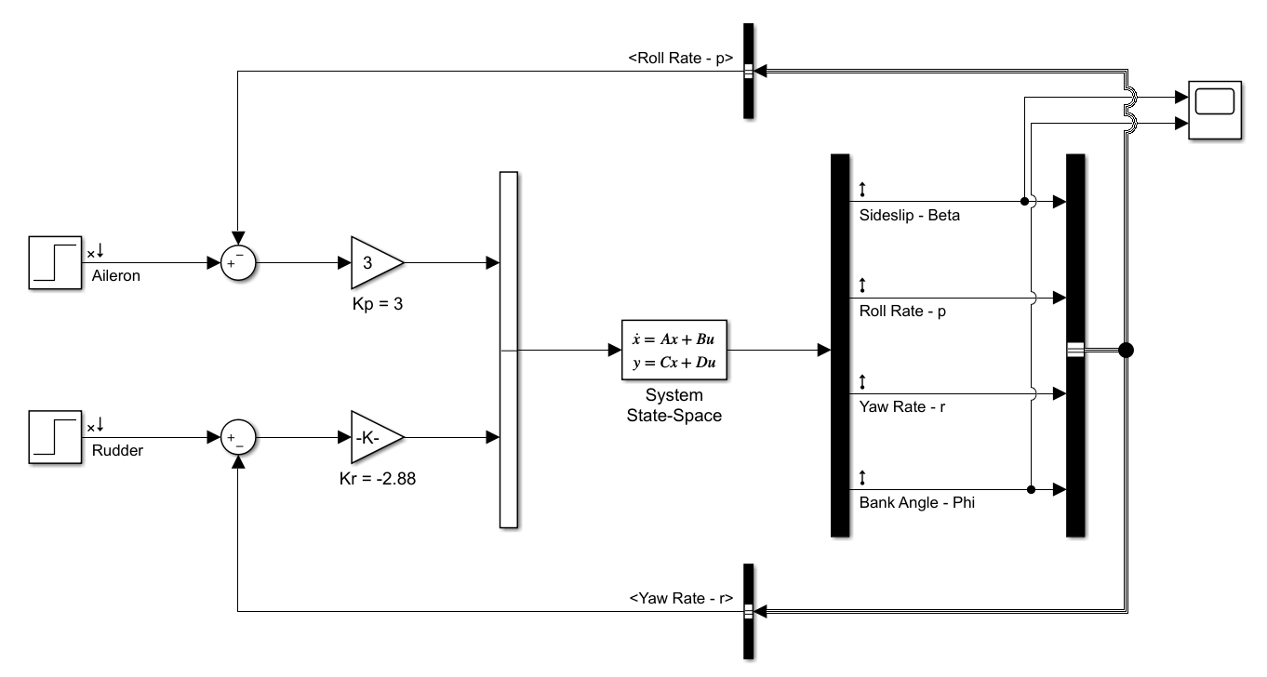
Question 2 – Coordinated Turn Hold Autopilot
- Autopilot Design
The following images show the root loci and pole locations for the gains in the autopilot which are Kbeta and Kphi
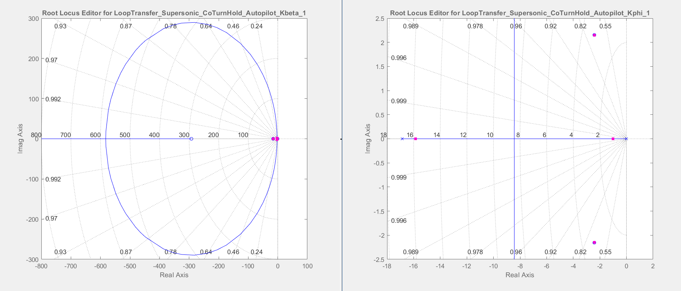

The below image shows the zoomed in root locus of the gain Kbeta
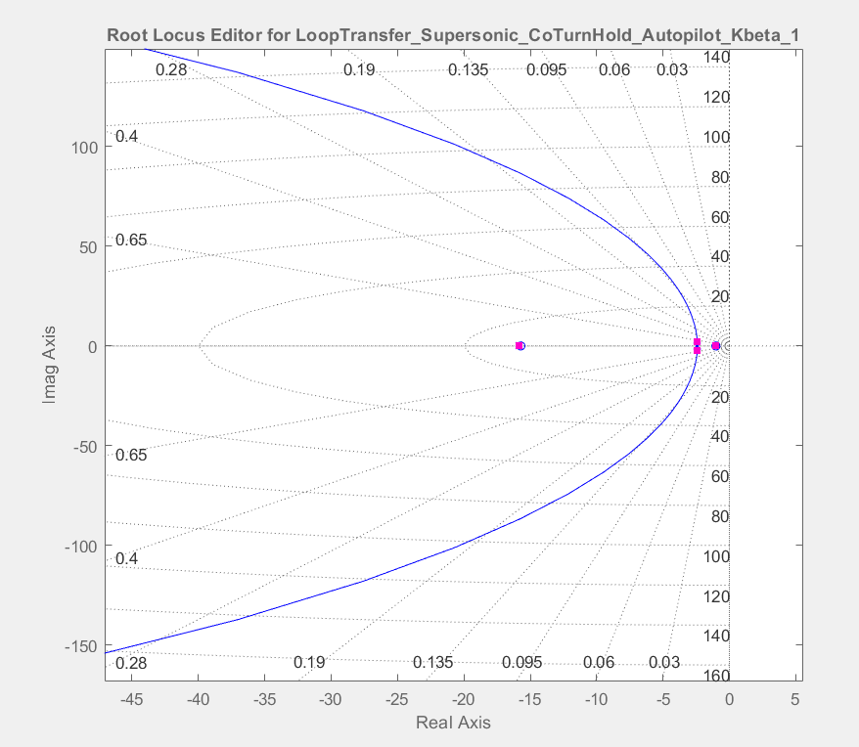
The gains selected for the autopilot are Kbeta = -1 & Kphi = 1
- Closed Loop Responses & Parameters
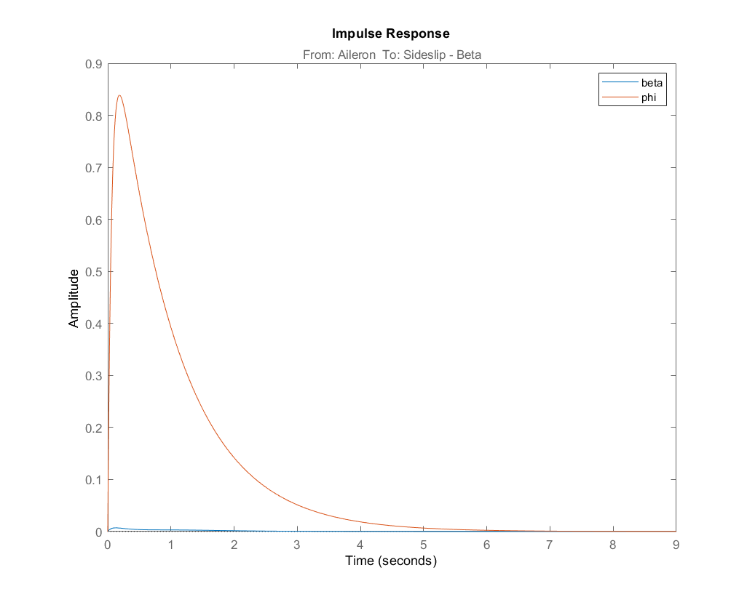

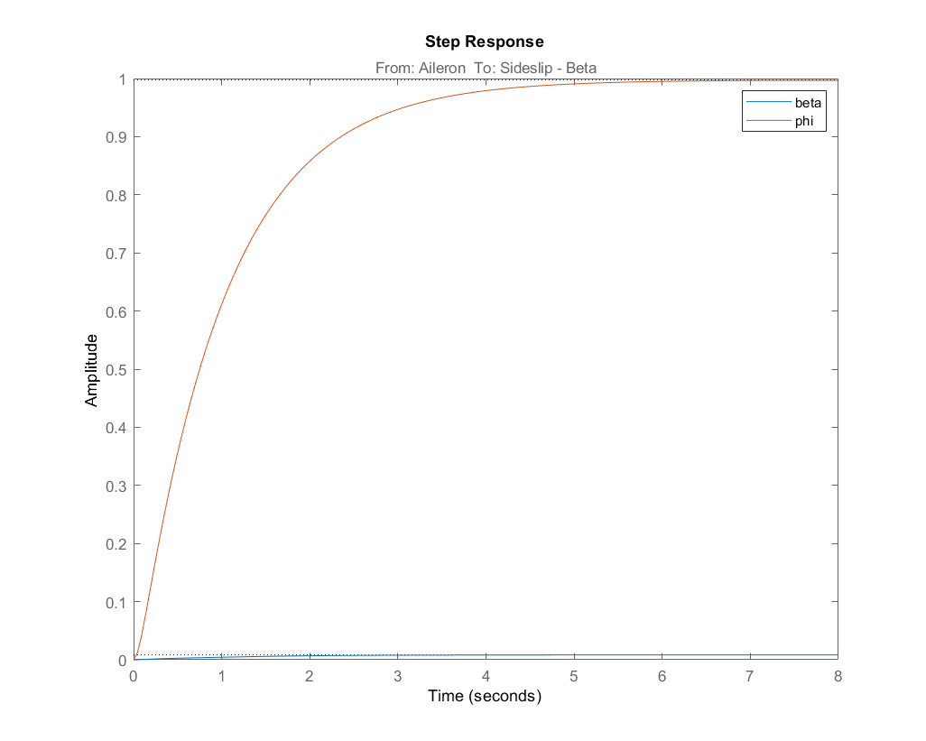
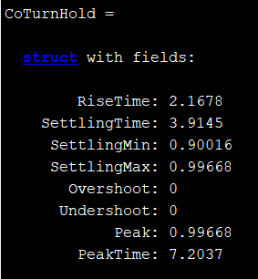
It is observed that sideslip beta remains zero as it should while a unit step response shows that the bank angle phi stabilizes at 1.

- Simulink Model for Coordinated Turn Hold Autopilot
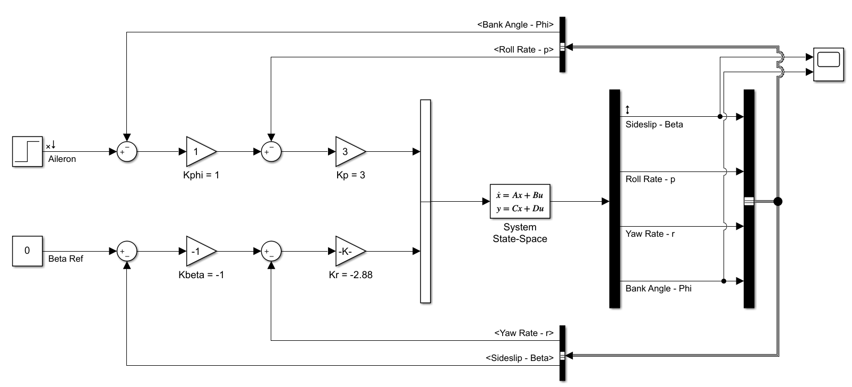
Question 3 – Heading Hold Autopilot
- Autopilot Design
This autopilot is almost the same as coordinated turn hold autopilot. There is just one extra feedback to the same structure as before and that is the heading Psi feedback. Below is the root locus for the heading feedback gain Kpsi. The value chosen for this gain is Kpsi = 10.
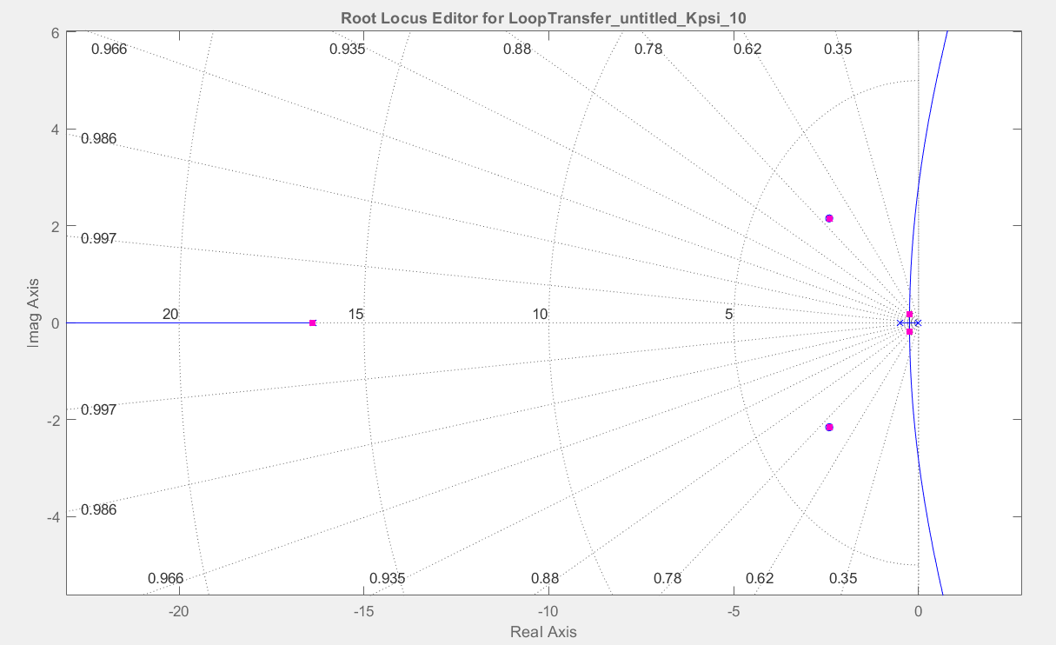

- Closed Loop Responses & Parameters
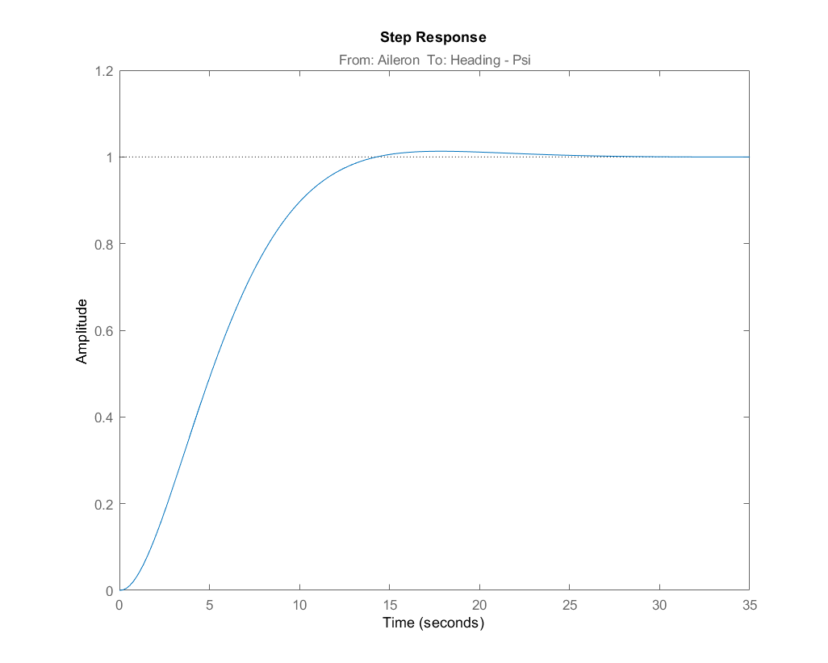
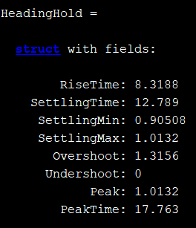
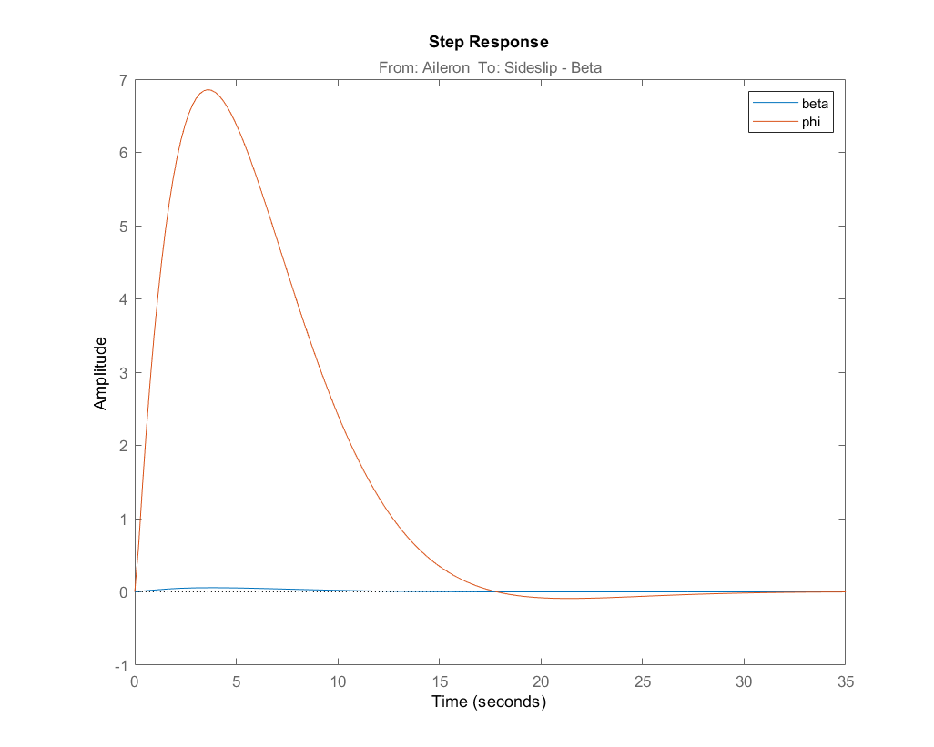
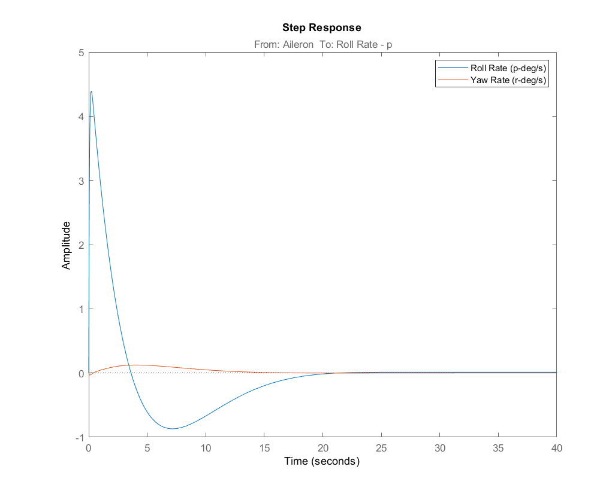

It is observed from the responses that the heading angle stabilizes at 1 due to unity step input. The beta angle remains almost zero while the phi angle first reaches a maximum and when the heading angle is about to be reached then comes back to zero to level off the wings. This can be observed from the moment rate graphs as well where the yaw rate almost remains zero but the roll rate first increases as bank angle increases and then decreases and comes back to zero when the wings have to be levelled once the heading is achieved.
- Simulink Model for Heading Hold Autopilot
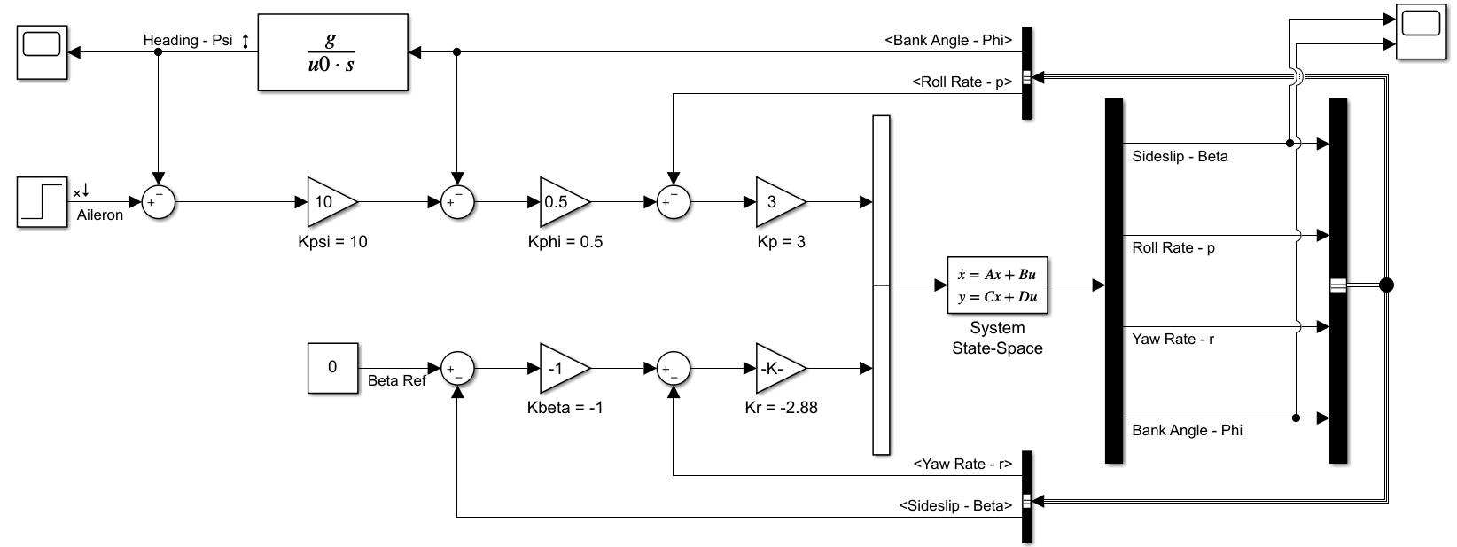

MATLAB CODE
% SUPERSONIC - FLIGHT CONDITION

% FlIGHT CONDITIONS
M = 1.8; % Approach mach number
u0 = 1742; % True airspeed
Q = 434.5; % Dynamic pressure
g = 32.2; % Gravitational acceleration

% AIRCRAFT PARAMETERS
S = 530; % Wing surface area
cbar = 16; % Mean aerodynamic chord
b = 38.7; % Wing Span
W = 39000; % Mass of aircraft in pounds
m = W/g; % Mass of aircraft in slugs
Ix = 25000; % Moment of inertia X-Axis
Iy = 122200; % Moment of inertia Y-Axis
Iz = 139800; % Moment of inertia Z-Axis

% Non-Dimensional Stability Derivatives
Cl_B = -0.025; Cl_p = -0.2; Cl_r = 0.0400;
Cy_B = -0.700; Cy_p = 0.00; Cy_r = 0.0000;
Cn_B = 0.0900; Cn_p = 0.00; Cn_r = -0.260; Cn_TB = 0;

Cl_delta_a = 0.01500; Cl_delta_r = 0.0030;
Cy_delta_a = -0.0100; Cy_delta_r = 0.0500;
Cn_delta_a = -0.0009; Cn_delta_r = -0.025;

% Dimensional Stability Derivatives
Y_v = (Cy_B*Q*S) / (m*u0); % Yv
L_v = (Cl_B*Q*S*b) / (Ix*u0); % Lv
N_v = (Cn_B*Q*S*b) / (Iz*u0); % Nv

Y_B = Y_v * u0; % Y Beta
L_B = L_v * u0; % L Beta
N_B = N_v * u0; % N Beta

Y_p = (Q*S*b*Cy_p) / (2*m*u0); % Yp
L_p = (Cl_p*Q*S*(b^2)) / (2*Ix*u0); % Lp
N_p = (Cn_p*Q*S*(b^2)) / (2*Iz*u0); % Np

Y_r = (Q*S*b*Cy_r) / (2*m*u0); % Yr
L_r = (Cl_r*Q*S*(b^2)) / (2*Ix*u0); % Lr
N_r = (Cn_r*Q*S*(b^2)) / (2*Iz*u0); % Nr

Y_delta_a = (Q*S*Cy_delta_a) / m; % Y delta a
L_delta_a = (Q*S*b*Cl_delta_a) / Ix; % L delta a
N_delta_a = (Q*S*b*Cn_delta_a) / Iz; % N delta a

Y_delta_r = (Q*S*Cy_delta_r) / m; % Y delta r
L_delta_r = (Q*S*b*Cl_delta_r) / Ix; % L delta r
N_delta_r = (Q*S*b*Cn_delta_r) / Iz; % N delta r

% State Space
A = [Y_B/u0 Y_p/u0 -(1-(Y_r/u0)) g/u0; L_B L_p L_r 0; N_B N_p N_r 0; 0 1 0 0];
B = [0 Y_delta_r/u0; L_delta_a L_delta_r; N_delta_a N_delta_r; 0 0];
C = [1 0 0 0; 0 1 0 0; 0 0 1 0; 0 0 0 1];
D = [0 0; 0 0; 0 0; 0 0];

states = {'Beta' 'p' 'r' 'Phi'};
inputs = {'Aileron' 'Rudder'};
outputs = {'Sideslip' 'Roll Rate' 'Yaw Rate' 'Bank Angle'};
sys = ss(A,B,C,D,'statename',states,'inputname',inputs,'outputname',outputs)

% MIMO
sys11 = sys('Sideslip','Aileron');
sys12 = sys('Roll Rate','Aileron');
sys13 = sys('Yaw Rate','Aileron');
sys14 = sys('Bank Angle','Aileron');

sys21 = sys('Sideslip','Rudder');
sys22 = sys('Roll Rate','Rudder');
sys23 = sys('Yaw Rate','Rudder');
sys24 = sys('Bank Angle','Rudder');

% Open Loop Analysis
disp('-----------OPEN LOOP ANALYSIS--------------')
Characteristic_Equation = poly(A)
damp(sys)
figure
step(sys)
openloop_step = stepinfo(sys23)

% Closed Loop SAS Analysis
disp('-----------CLOSED LOOP SAS ANALYSIS--------------')
damp(clsys)
figure
step(sys)
hold on
step(clsys)
figure
impulse(sys)
hold on
impulse(clsys)
clsys23 = clsys('Yaw Rate - r', 'Rudder');
closeloop_step = stepinfo(clsys23)

% Coordinated Turn Hold Autopilot
disp('-----------Coordinated Turn Hold Autopilot--------------')
figure
step(BetaToAileron1)
hold on
step(PhiToAileron1)
legend('beta','phi')
CoTurnHold = stepinfo(PhiToAileron1)
figure
impulse(BetaToAileron1)
hold on
impulse(PhiToAileron2)
legend('beta','phi')

% Heading Autopilot
disp('-----------Heading Autopilot--------------')
figure
step(HeadingAngle)
HeadingHold = stepinfo(HeadingAngle)
figure
step(BetaToAileron3)
hold on
step(PhiToAileron3)
legend('beta','phi')
figure
step(RollRate1)
hold on
step(YawRate1)
legend('Roll Rate (p-deg/s)', 'Yaw Rate (r-deg/s)')

